**1. Why does a Hash algorithm fail? Your answers should include the term**

**‘collision Resistant’.**

Collision resistance is a property of hash functions in which it is difficult for two inputs to hash to the same output. So, if a hashing function is not collision resistant then two values may possibly have the same hash, and therefore an account is susceptible to another password than the initial.

**2. Inquire about the relationship that exists between hashing functions and cryptocurrency, write a summary of your findings. (minimum of 100 words).**

In relation to cryptocurrency, the hashing of transactions occurs before being added to a blockchain – a system in which a record of transactions are made and maintained across several computers linked via peer-to-peer network. Crucial Information such as new transactions, timestamps, and previous references are recorded and added to the blockchain. The hash maintains the integrity of the blockchain as it would be near impossible to reverse or alter due to the computing power required to tamper with the blockchain. Ultimately, the hash function validates the blockchain across a network and allows for the safe exchange of cryptocurrency among users.

**3. Mention 2 advantages and 2 disadvantages of using Brute Force attack**

Checks all possible password and is generally simple to setup, however, it is hardware intensive and takes a lot of time.

**4. Mention 2 advantages and 2 disadvantages of using Dictionary attack.**

People generally use normal phrases as passwords as they are easy to remember and the time to execute dictionary attacks is reduced due to the limited dictionary list given, however, there is less coverage of passwords so it may not work as well and it also fails against more random passwords.

**5. Read the article** [**https://nakedsecurity.sophos.com/2016/08/18/nists-new-password-rules-what-you-need-to-know/**](https://nakedsecurity.sophos.com/2016/08/18/nists-new-password-rules-what-you-need-to-know/) **Do you agree or disagree with the NIST password rules? Give reasons to support your position.**

I agree with the NIST password rules, it removes limits from passwords that are harmful and adds guidelines that would improve security. For instance, ‘no password hints’ and ‘knowledge-based authentication’ is a vulnerability which provides information about you and your password. While ‘size matters’ would set a minimum of at least 8 characters, increase the maximum to 64, and allow for ASCII, Unicode, and even emojis which would make cracking passwords more difficult and time consuming. Of course, password recovery options would be affected the most and would need to be altered as well but I would support the accommodation of that as well if it led to increased security.

**6. Provide an example of using a flag not covered in the lecture for the crunch command, we used -f -t and -p flags. Provide a screesshot and explain the output.**

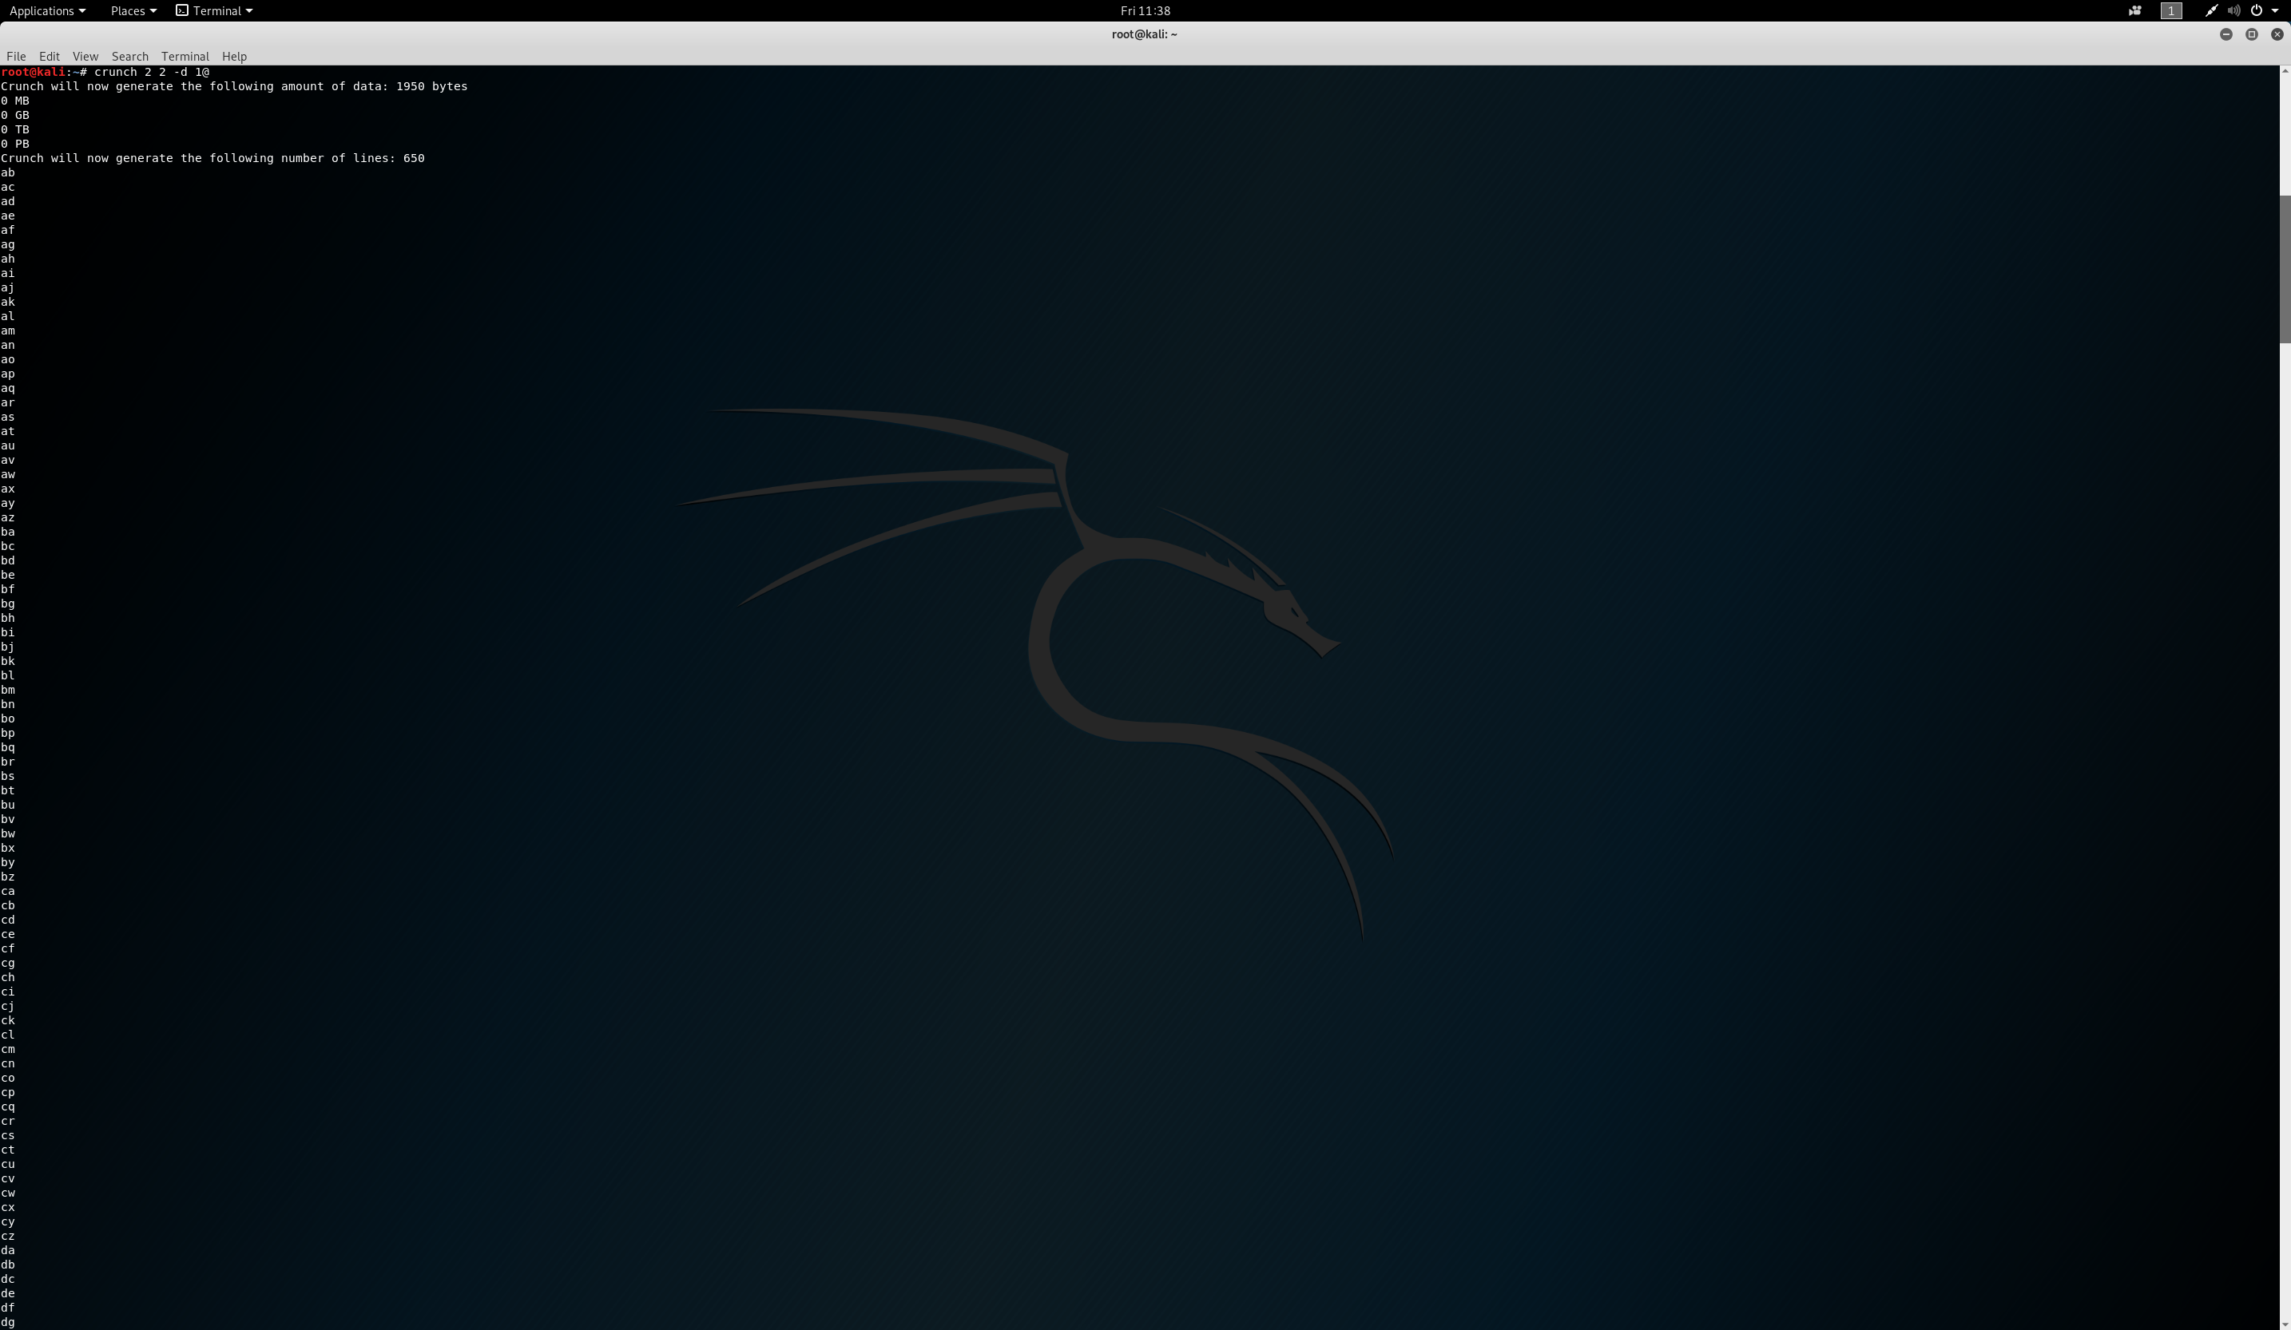

crunch 2 2 –d 1@

crunch – creates wordlist based on specified criteria

2 2 - the minimum length of the string, the maximum length of the string

-d limits the number of duplicate characters

1@ - the maximum number of consecutive characters, and the character set you want to limit

So, the generated wordlist is a set of two characters from (a@ - z@) where there is no consecutives generated in the @ slot (there is no aa, bb, cc, etc.)

**7. By using hydra tool agains Metasploitable 2, we were able to ennumerate: ftp, user, postgres and service accounts. Use the service account with ftp over Metasploitable 2 to verify if there is some useful information for that account. Describe your findings and attach a screenshot.**

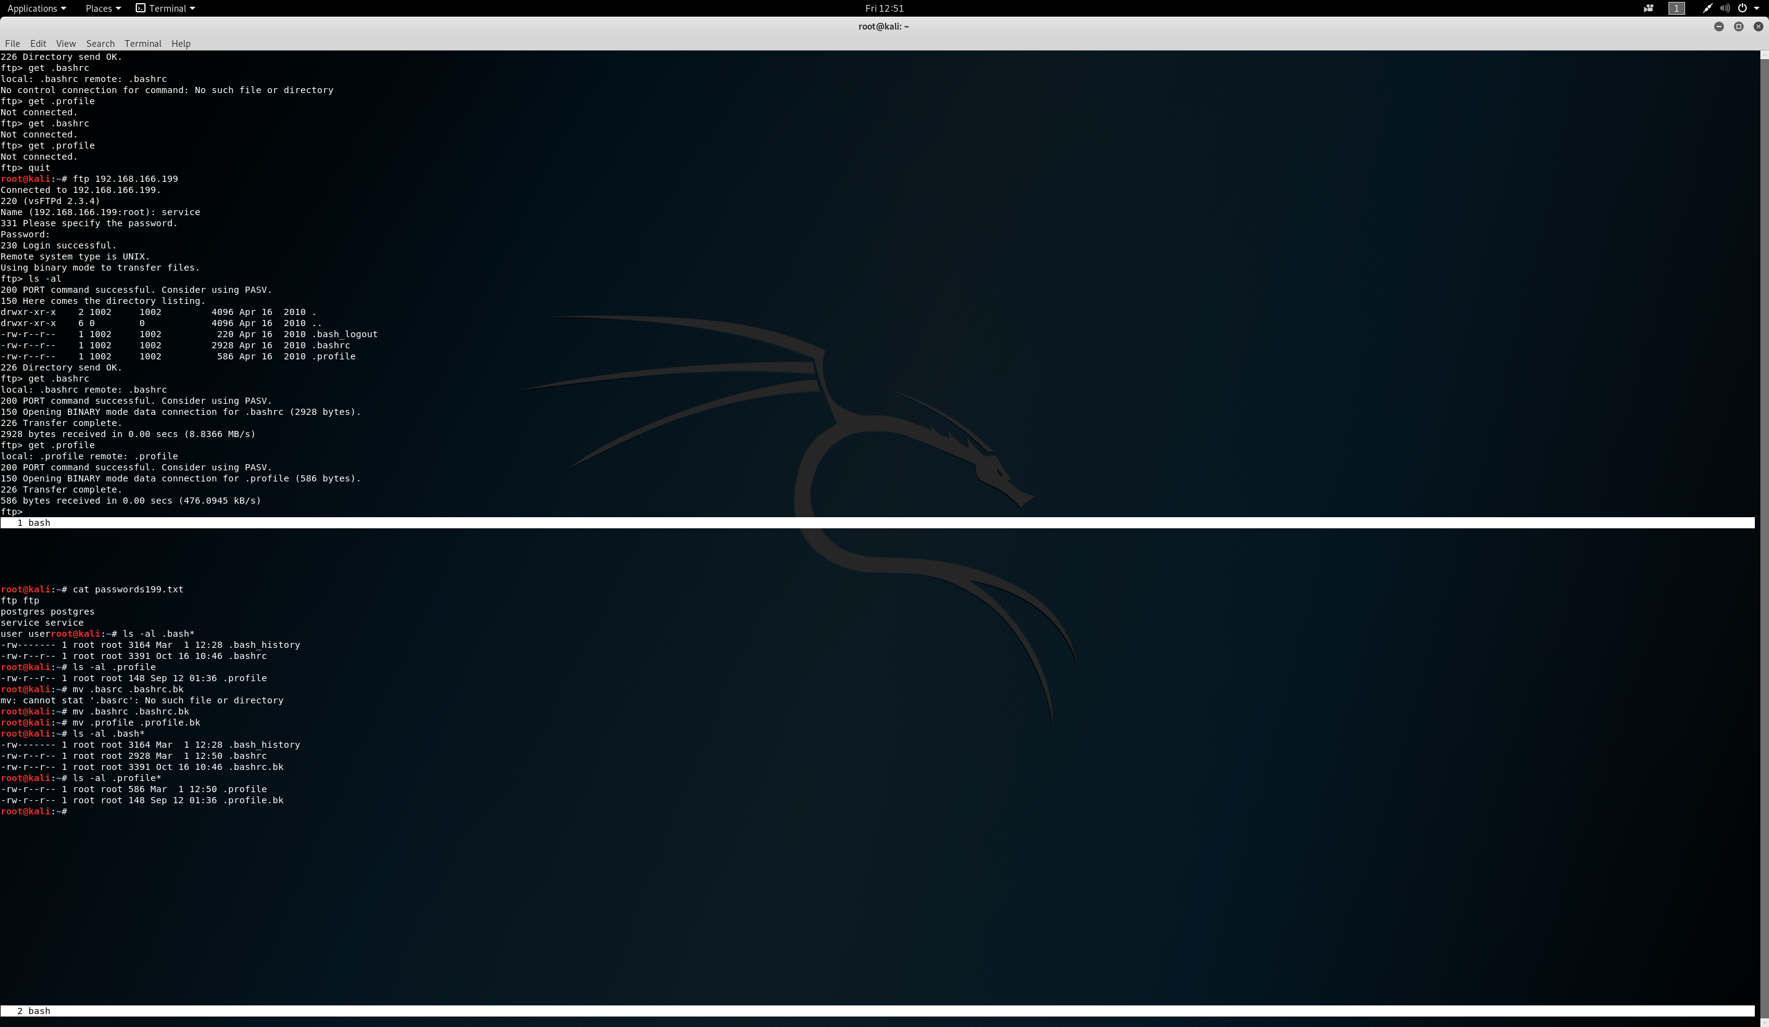

The service account contained .bash_logout, .bashrc, and .profile. The .bash_logout is a shell which executes upon logging out and contains commands users would execute upon leaving. The .bashrc is a shell which initializes a shell session. Finally, the .profile initializes the files you have set up when logging in.

**8. Inquire about the medusa tool and obtain a similar output as we did with the hydra tool i.e. find 4 users accounts and 4 passwords. Include a screenshot.**

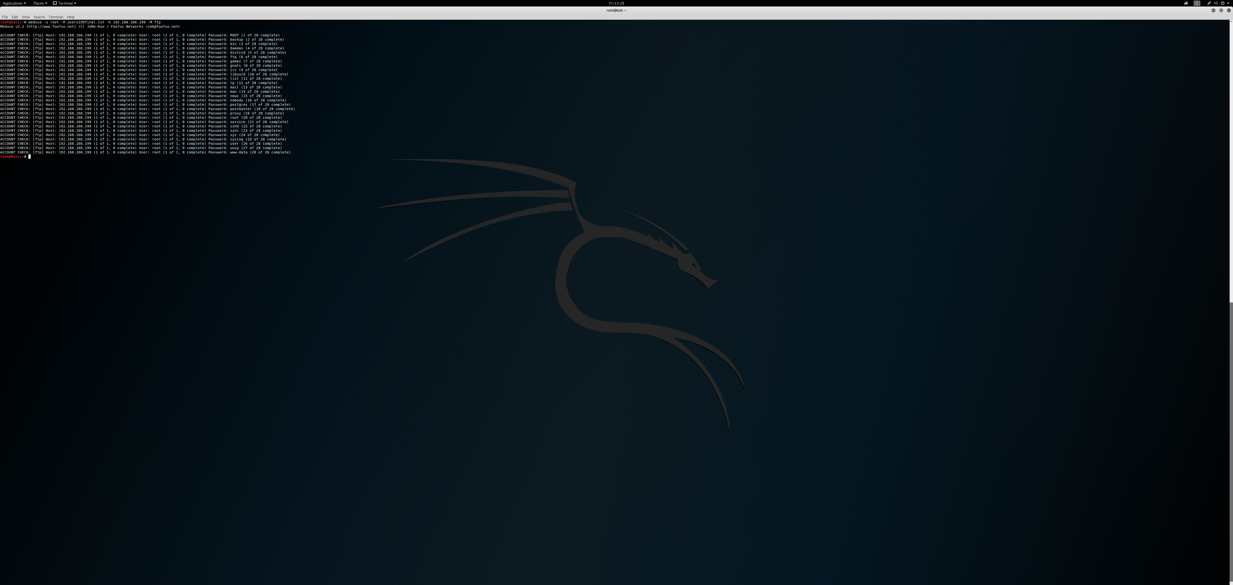

**9. We used the user account with ftp to download a private key to our local system from Metasploitable 2. One of the commands that the user account executed (according to the bash_history file) was:**

**sudo cat ~/.ssh/id_rsa.pub >>**

**/home/msfadmin/.ssh/authorized.keys**

**From the previous command, we can see that apparently there is a msfadmin home directory for a msfadmin user.**

**Verify if you can ssh to Metasploitable 2 by using msfadmin user and the private key you downloaded from there. Include a screenshot.**

